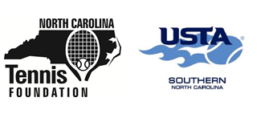

Coaches,
I hope you all are well, safe and in good health. With the COVID-19 pandemic still present, I understand the outlook on the 2020-21 tennis seasons is different than ever before. The whole situation has been very fluid and at times frustrating. I know how much time and dedication all of you have spent trying to prepare practice plans and often going above and beyond in doing so. Our world has changed, and we don’t know when things will be back to ‘normal.’ But much like you do when coaching or teaching, you adjust and adapt to the circumstances around you.

USTA-North Carolina is still committed to supporting high school tennis. Here is an overview of the resources we have available:

- Access to video demonstrations of the Net Generation team practice plans from the USTA
- How to register for Net Generation and receive full access to the practice plans and other resources for FREE
- Fact sheet on all the offerings USTA-NC and North Carolina Tennis Foundation have that impact high school tennis players and coaches.
- Grants for your team, including the Emily H. Preyer High School Team Grant. This grant provides support to High School Tennis Teams in North Carolina and can be used for equipment, supplies (including items needed for meeting covid-19 requirements), facility projects, and more. Do not include uniforms in the request. Please fill out all parts of the attached form and be as detailed as possible with your proposal. To apply, click this link: High School Team Grant Application

Despite the circumstances of COVID-19, we are hopeful you all will still be able to have a season. Be on the lookout for information from us throughout the year with exciting updates in the world of tennis and high school tennis. Please reach out to us if you have any questions. Good luck this season!

Sincerely,

USTA-North Carolina and the North Carolina Tennis Foundation
2709 Henry Street
Greensboro, NC 27405
336-852-8577

